# Command-line CSEEgit: QuickStart

This guide tells you how to copy all of your java code quickly onto the git server.

0. First ensure git is installed on your machine.  Note that git is installed on university lab machines and Linux and Mac by default, but if you are using your home windows machine then you will need to install it manually.  See <https://git-scm.com/book/en/v2/Getting-Started-Installing-Git> for details.  If you find this step too difficult, then please connect remotely to university lab machines using the [https://csee-horizon.essex.ac.uk](https://csee-horizon.essex.ac.uk/) link, where you will find git and all other necessary software preinstalled.

1. Login to the cseegit webserver at [https://cseegit.essex.ac.uk](https://cseegit.essex.ac.uk/ce812), and sign in with LDAP using your Essex login-id (without the @essex.ac.uk) and usual Essex password.

2. Go to [https://cseegit.essex.ac.uk/](https://cseegit.essex.ac.uk/ce812) and click on your own repository

3. Add a .ignorefile file (if it’s not already present), by following the instructions "Using a .gitignore file with Java" modified for whichever language you are using, which can be found in the ‘General Resources’ tile.

4. Open a terminal or Windows-PowerShell environment, and cd to an appropriate folder where you have write access.  On university a lab machine this can be done quickly by doing shift right-click in an appropriate folder where you have write access, and selecting "Open Powershell".

5. If you’ve never used git before on your university account, type in the following two lines, which will tell git who you are, changing the names and email address to your correct name and correct university email address:

git config --global user.name "Firstname Surname"

git config --global user.email "login@essex.ac.uk”

6. Find the “Clone with HTTPS” URL of your git repository, found here:

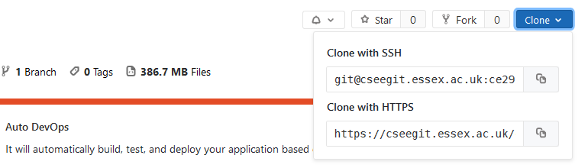

7. git clone URL

8. When prompted, enter your Essex login-id and password. (Tip: If you type the password wrong at this stage, then Windows will unhelpfully save and use the wrong password from now on, preventing you from ever logging in again. See the ‘Tips and Tricks and FAQ’ file in the ‘General Resources’ tile for what to do next.)

This will create a local folder *repository_name* which is a complete local copy of the git repository from the cseegit webserver.

9. ls

10. cd *repository_name*

11. Copy your files, i.e. the entire folder structure, into your *repository_name* folder. You can use windows file manager to do this copying, or use the cp command if you know how.

12. ls

13. git add .

14. git status

15. git commit -m "appropriate message"

16. git push

17. Check on webserver that it's arrived. It should look something like this:

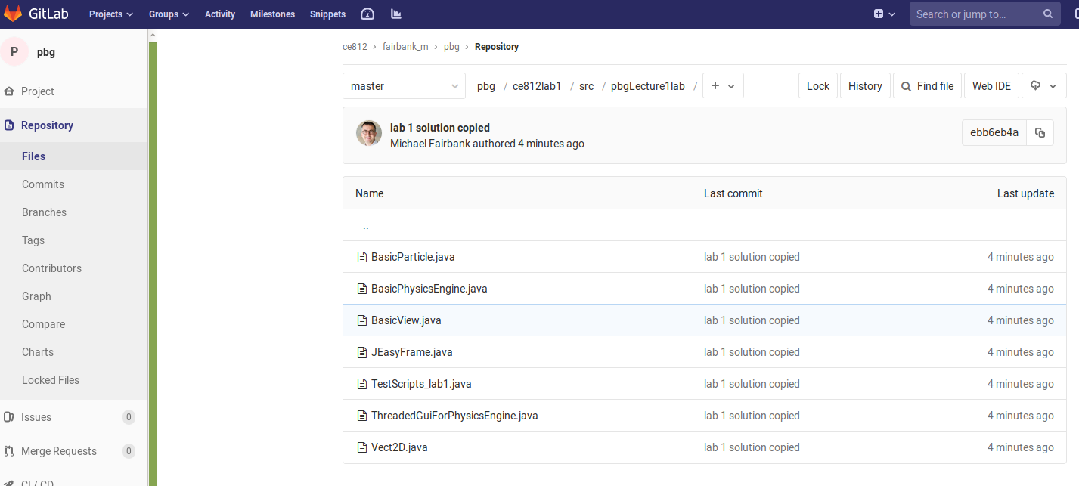

Next time you do this, skip steps 3 and 5, and replace step 7 by "git pull".

This guide gives you the minimal amount of information you need to know to be able to upload your work. If you want to learn more, and to work more efficiently, then you can get IntelliJ/Ecplipse to save directly to a local copy of your git repository, and also update to the server using GUI tools. To learn more about this look at the gitlab resources located in the ‘General Resources’ tile.